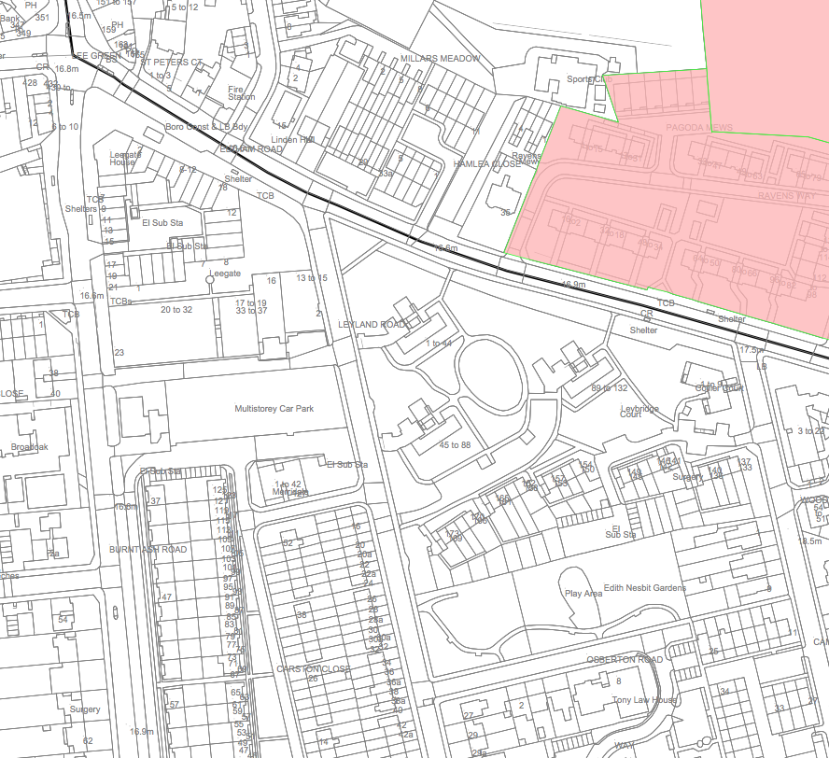
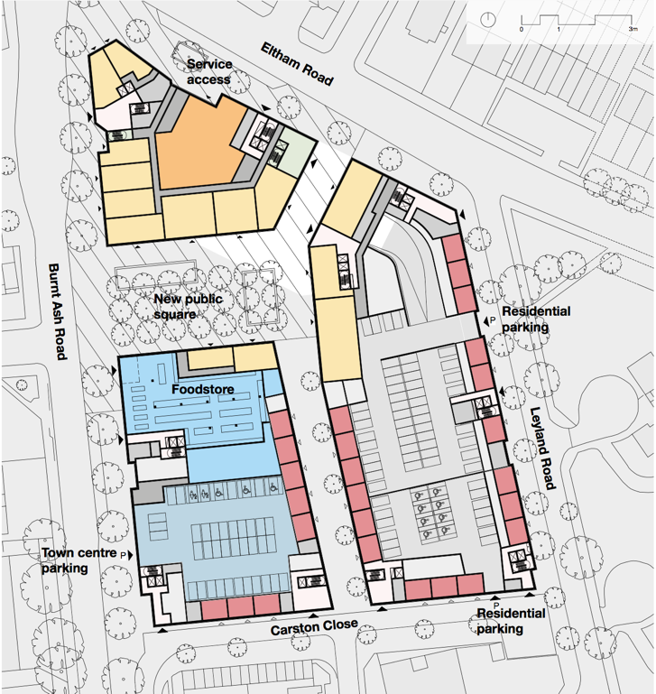
Leegate July 2017
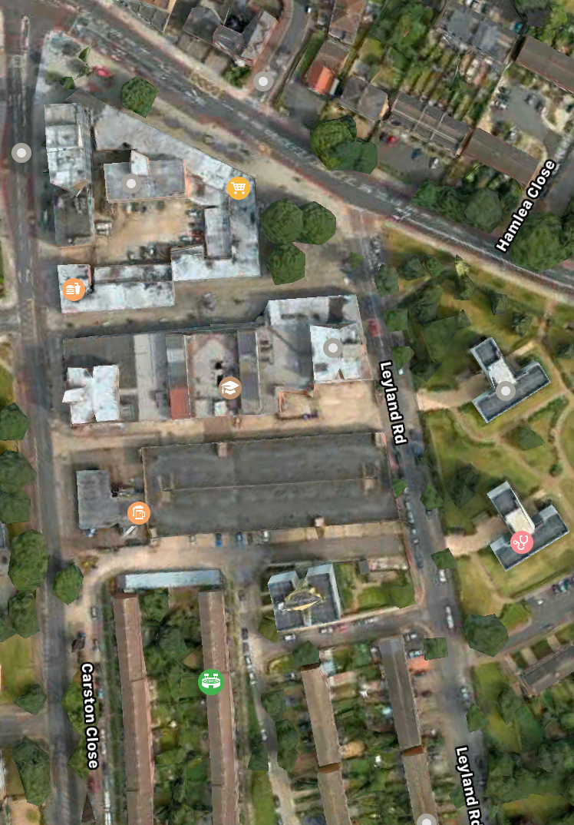
Overlays: reference map, plan of proposed ground floor, aerial view

Smallest layer is on top – plan of proposed ground floor
Middle layer is aerial view (small amount of parallax error)
Largest (lowest) layer is reference map
Use ‘transparency’ control in MS Word to adjust relative content

